**BIOINFORMATICS ASSIGNMENT 1 (Day 1 - 5)**

1. Gene Name: HIF1 alpha

2. Function of the Gene: This gene encodes the alpha subunit of transcription factor hypoxia-inducible factor-1 (HIF-1), which is a heterodimer composed of an alpha and a beta subunit. HIF-1 functions as a master regulator of cellular and systemic homeostatic response to hypoxia by activating transcription of many genes, including those involved in energy metabolism, angiogenesis, apoptosis, and other genes whose protein products increase oxygen delivery or facilitate metabolic adaptation to hypoxia. HIF-1 thus plays an essential role in embryonic vascularization, tumor angiogenesis and pathophysiology of ischemic disease.

3. NCBI accession number: NC_000014.9

4. Forward Primer: TGGGAGGCCATTTAAGCTCA

5. Reverse primer: CAGCTCACAGAACTCAGGGA

6. Features of primers:

Length of the primers : 20

GC content : 50 % in forward primer and 55% in reverse primer

Melting temperature of the forward primer : 59.00

Melting temperature of the reverse primer : 59.03

7. Amplicon length and sequence:

Amplicon length : 187

Amplicon sequence : TGGGAGGCCATTTAAGCTCAAAGGCTATTCTACTTCTCACTATATTTCTAGTACCTAGCACAGTGCATGGTACTTGATAGATGCATCCTTTCTCCCATACCTCGCCCTACACATCTCTTCATGTGTATCCTTATTAATATCCTCTATTATAAACTGGTAAACATGTTTCCCTGAGTTCTGTGAGCTGC

**qPCR Data analysis (DAY 5)**

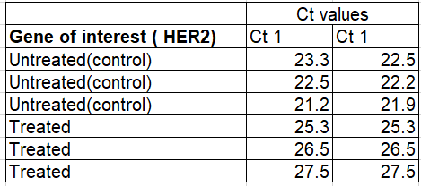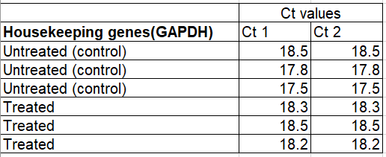

The following data are results of qPCR from cancer cell lines. HER2 stands for human epidermal growth factor. It’s healthy in normal amounts, but too much may be a sign of a certain type of breast cancer. Calculate the 2 Delta Ct values for the following data and plot the values on a graph using graphpad prism.